Marshall,

Here’s the new material. Please delete the copy I previously sent for the slide show and services, and replace it with what’s on the following pages. Also, I’d like to see two or three design options for the logo and tagline.

The above-the-fold design that follows is rough, and may look a bit too “black heavy.” Feel free to refine as you see fit, so long as we keep it crisp and bright. I like the three colors at work here: red, black and the various shades of vivid blue that appear in the original photo. As discussed, I prefer these kinds of blues (crisp and vivid, even in its lighter shades) to the soft, pastel blue you used in the Services section. Same for the color that backgrounds the Projects section: as discussed, we’ll make it less brown and a bit whiter – like a crisp, linen white. You’ll decide – I trust your taste.



**Noisy markets create a stark choice for all who sell: be vivid or be gone.**

**We produce *vivid*: communications that pierce the din.**

**It’s noisy out there.**

**You get ten seconds to earn the next ten seconds.**

**SLIDE SHOW SECTION** (Marshall, when laying out the text, please feel free to play with line breaks as needed; the line breaks in the following copy are purely arbitrary. The paragraph breaks, however, should remain as is.)

PROJECTS

Think of us as you would a cloud service: there when you need us, up to speed quickly,

remarkably effective, and gone when our work is done; available to re-engage instantly.

Presentations

Ok, life is like a box of chocolates. But a great

presentation is like a strand of pearls: each slide

is a gem and together they make a statement.



The statement we helped craft for Cognitive Networks,

providers of content-recognition technology for

Smart TVs, distilled the complexities of media

measurement into a series of vivid decks designed to

answer one question: With set-top-box data and Nielsen

ratings so widely used, why would broadcasters

need *more* insights into what’s on each screen?

The answer boils down to this: “Showtime” is vastly

more profitable when networks know who’s watching

in *real* time.

Collateral

What a difference a day makes!

How to prolong current growth while concurrently

building its next stage? Give us a day, Deloitte tells

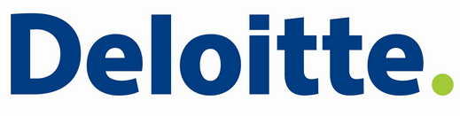clients, and we’ll take you a giant step forward. Its

means is a tool called DeepDive™ -- a mix of

brainstorming, prototyping and feedback loops –

by which routine strategy meetings become

uniquely-productive exchanges; the one day that

sets up years of growth.

Engaged to market this initiative, bVIVID saw this:

with its candid, high-velocity interactions, DeepDive™

is more than a meeting; it’s a bona-fide intervention

to harness the collective IQ.

Success Stories

The art of elevating customer loyalty comes easily to

Virgin America. But for the science it turns to TIBCO,

whose data technologies automate the inner workings

of Virgin’s loyalty program.

TIBCO calls its proposition the Two-Second Advantage™:

capture the right data, at the right time, and you can use

it proactively to build customer loyalties, cross-sell, and

enable a thousand other actions intrinsic to seizing

opportunities and mitigating risk.

How to market the Two-Second Advantage™? Show what

it makes possible, through a continually refreshed repertoire

of customer success stories. To produce these and more,

TIBCO turns to bVIVID.

Keynotes

China’s markets don't exist for the taking; a seller has to

offer added value. When the seller is PepsiCo, no offer is

more valuable than help in purifying water.

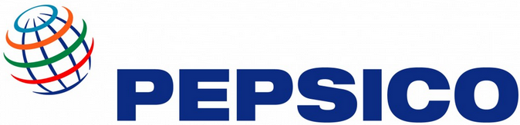

Eager to embed itself in China's ascent, PepsiCo has invested

vigorously to bring clean water to the country’s neediest

regions. When PepsiCo’s Indra Nooyi planned her first visit

as CEO, she tapped bVIVID to write her keynote ─ a moving

proclamation of her company’s commitment to the world’s

most populous nation.

bVIVID prepares keynoters for all podiums, from industry

gatherings and investor conferences to venues like The

World Economic Forum.

Bylined articles

What does Vendavo CMO Joe Boissy have in common

with Time Warner CEO Jeff Bewkes and New York Times

Publisher Arthur Sulzberger? All are bylined contributors

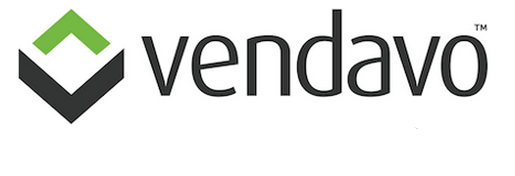to *The Economist,* Joe with an assist from bVIVID.

Vendavo’s software drives margin optimization across the

Global B2B 2000. The article we wrote for Joe ─ a reasoned

plea to sales teams to hold the line on the right price ─

spoke powerfully to Vendavo’s targets and struck a chord with

*Economist* editors.

There’s great value in communicating your proposition

through prominent media, under your byline, and in your own

words. We’ll get it done for you.